CLASS: B.E. E &TC SUBJECT: ML

EXPT. NO.: 4 DATE:
ROLL NO.:

TITLE: Radial Basic Functions

CO 4: Design and implement convolutional neural networks for application for object recognition. Compare the results obtained using deep learning approach with traditional neural networks in terms of number of hidden layers, number of epochs, training error and testing error.

CO 5: Carry out experiments as an individual and in a team , comprehend and write a laboratory record and draw conclusions at technical level.

SOFTWARES REQUIRED: MATLAB 7.0 or Python

THEORY:
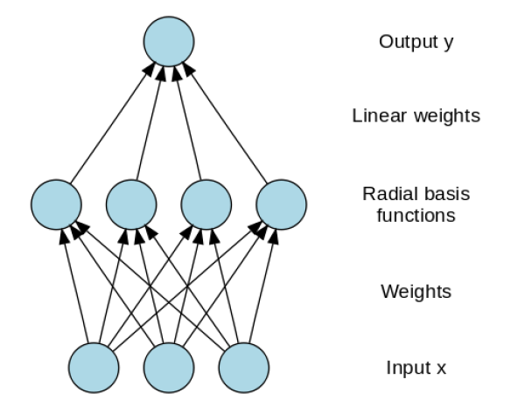

In Single Perceptron / Multi-layer Perceptron (MLP), we only have linear separability because they are composed of input and output layers (some hidden layers in MLP)
- For example, AND, OR functions are linearly-separable & XOR function is not linearly separable.

Linear Separability

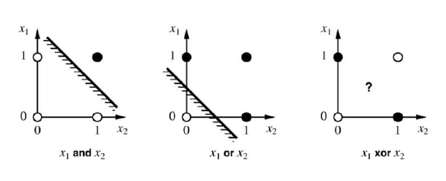
Linear-separibility of ANDM OR, XOR functions

One hidden layer is required to derive a non-linearity separation.
- RBNN transforms the input signal into another form, which can be then feed into the network to get linear separability.
- RBNN is structurally same as perceptron (MLP).

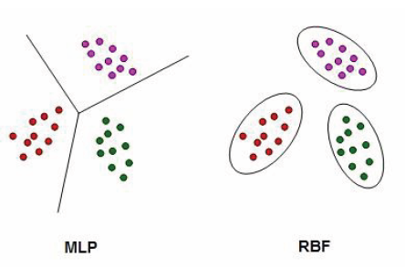
Distinction between MLP and RBF

- An MLP would separate the classes with hyper-planes in the input planes while RBF model separate class distributions by localized basis functions
- RBNN is composed of input, hidden, and output layer. RBNN is strictly limited to have exactly one hidden layer. This hidden layer as feature vector.
- RBNN increases dimension of feature vector.
- Main features
- They have two-layer feed-forward networks.
- The hidden nodes implement a set of radial basis functions (e.g. Gaussian functions).
- The output nodes implement linear summation functions (similar to MLP). The network training is divided into two stages:
- The weights from the input to hidden layer are determined
- Then the weights from the hidden to output layer are found.
- The training/learning is fairly fast.
- RBF nets have better performance than MLP in some classification problems and function interpolation

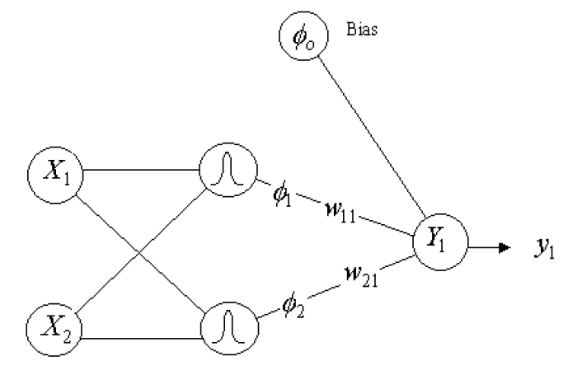
Simplest diagram shows the architecture of RBNN

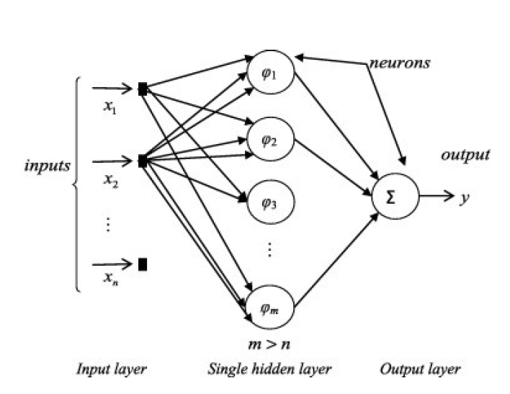
Extended diagram shows the architecture of RBNN with hidden functions.

Non-linear transfer function is applied to the feature vector before go for classification problem.
- When user increase the dimension of the feature vector, the linear separability of feature vector increases.
A non-linearity separable problem (pattern classification problem) is highly separable in high dimensional space than it is in low dimensional space.
- Gaussian Functions are generally used for Radian Basis Function (confrontal mapping). So, the radial distance r = ||x- t||.

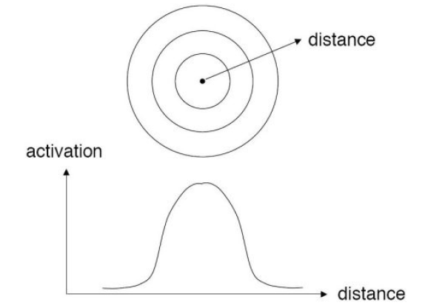
Radial distance and Radial Basis function with confrontal map Gaussian

Radial Function :=ϕ(r) = exp (- r²/σ²)
where σ > 0

As Gaussian potential function are being used, each node is found to produce an identical output for inputs existing within the fixed radial distance from the center of the kernel,they are found to be radically symmetric, and hence the name radial basis function network

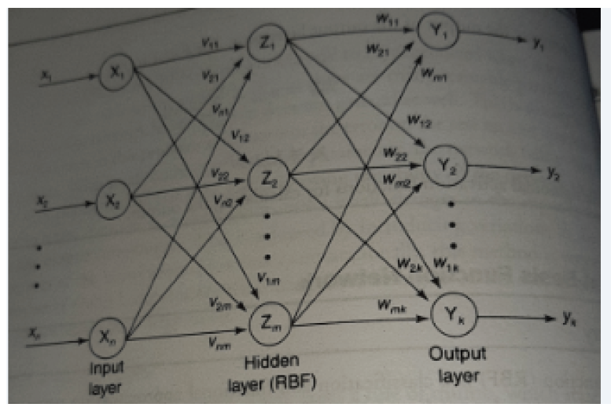
Architecture of RBF

Architecture for RBFN is shown in figure. The architecture consists of two layers whose output nodes from a linear combination of the kernel(or basis )functions Computed by means of the RBF or hidden layer nodes. The basis function(non linearity)in the hidden layer produces a significant non zero responses to the input stimulus it has received only when the input of it falls within a small localised region of the input space. This network can also be called as localised receptive Field network.

Training Algorithm:
The training is started with hidden layer with an unsupervised learning algorithm. The training is continued in output layer with supervised learning algorithm.
Simultaneously, we can apply supervised learning algorithm to the hidden and output layer for fine tuning of the network.

Step 0: Set the weights to small random values
Step 1: Perform steps 2-8 when stopping condition is false
Step 2: Perform Steps 3-7 for each input
Step 3: Each input unit (xi for all i= 1 to n)receives input signals and transmit to the next hidden layer unit
Step 4: Calculate the radial basis function.
Step 5: Select the canters for the radial basis function. The centres are selected from the set of input vectors. It should be noted that sufficient number of centres have to be selected to ensure adequate sampling of the input vector space.
Step 6: Calculate the output from the hidden layer unit
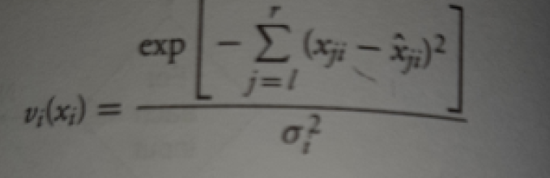

Where xij^ is the centre of RBF unit for input ;σi the width of ith RBF unit; xji the jth variable of input pattern.

Step 7: Calculate the output of neural network
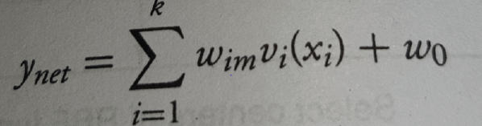

Where k is the number of hidden layer (RBF function); ynet is the output value of m^{th} node in output layer for n^{th} incoming pattern; wim the weight between i^{th} RBF unit and m^{th} output node; w0 the biasing term at nth output node.
Step 8: Calculate the error and test for stopping condition. The stopping condition may be number of epochs or to certain extent weight change.

Training in RBNN is faster than in Multi-layer Perceptron (MLP) → however; Classification will take more time in RBNN than MLP. Classification only happens on the second phase, where linear combination of hidden functions are driven to output layer.

An RBFN (in its most basic form) has a single hidden layer. But an MLP may have one or more hidden layers.
RBF networks tend to use Gaussian function at the hidden layer
In MLP the computation nodes in different layers share a common neural model (not necessarily the same activation function). But in RBFN, the hidden nodes (basis functions) operate very different and have different purpose to the output nodes.
In RBFN, the argument of each hidden unit activation function is the distance between the input and the weights (RBF canters), But in MLPs it is the inner product of input and the weights.

Other applications of RBFN are in:
- Model prediction
- Speech-hand writing recognition
- Highly non-linear systems
- Time series analysis
- Medical diagnosis

CONCLUSION:
Radial basis functions are means to approximate multivariable (also
called multivariate) functions by linear combinations of terms based on a single univariate function (the radial basis function). This is radialised so that in can be used in more than one dimension. They are usually applied to approximate functions or data which are only known at a finite number of points (or too difficult to evaluate otherwise), so that then evaluations of the approximating function can take place often and efficiently.

REFERENCES:
- Phil Kim, "MATLAB Deep Learning: With Machine Learning, Neural Networks and Artificial Intelligence", a Press 2017
- MATLAB Deep Learning and Computer Vision System Toolbox Documentation
- Laurene Fausett ,"Fundamentals of Neural Networks: Architectures, Algorithms and Applications", Pearson Education, Inc, 2008.
- S. N. Sivanandam , S. Sumathi, S. N. Deepa, "Introduction to Neural Networks using MATLAB", McGraw Hill, 2006.
- S. N. Sivanandam, S. N. Deepa, "Principles of Soft Computing" , John Wiley & Sons, 2007

(Course Teacher)

